Server-side rendering

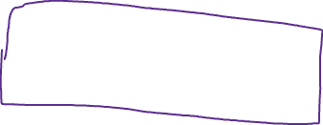

Web browser (client)

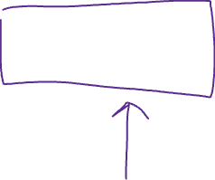

Backend

HTML, CSS JS

Javalin

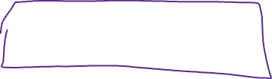

Thymeleaf

= Data (JDBC) + HTML



JDBC

SQLite